Day 1 Assignments

**Maged Eshak - Minya Branch**

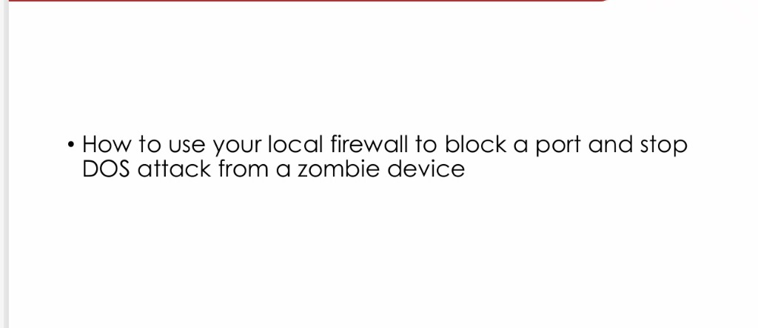

To prevent a DOS attack from a zombie device using My local firewall, follow these steps:

1. Open the Firewall settings in Windows.
2. Go to the Advanced settings section and locate "Inbound Rules."
3. Create a new rule to block the specific port used by the attack.
4. Choose "Port" then “Next” Choose “TCP” or “UDP” then Write “Specific local port”.
5. Choose "Block the connection" when setting up the rule to stop any traffic on that port.
6. Save the changes and regularly update your firewall settings.